# DEFINE STRING IN SKYDRM DESKTOP

All string must be defined in StringResource.xaml ,the url:SkydrmLoacl/Resources/langues/StringResource.xaml

# How to operate?

Before defining a string, please read the note at the beginning and the notice for each section in StringResource.xaml. It maybe help you.

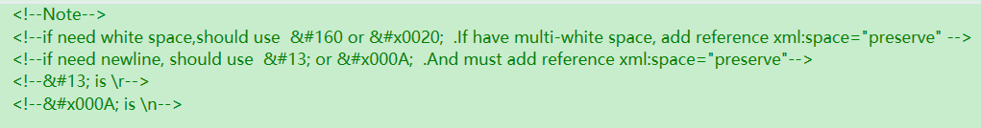

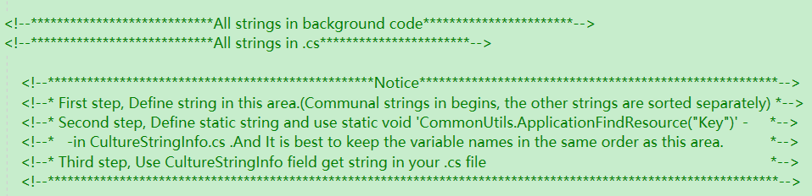

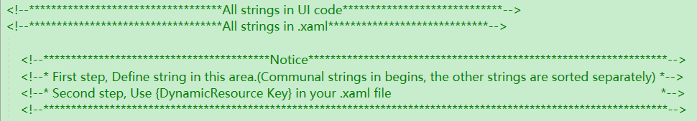

The StringResource.xaml separate into two parts:

First part: All the strings in the .cs file are added in this section.



Steps: First step, Define string in this area .(Communal strings in begins, the other strings are sorted separately)

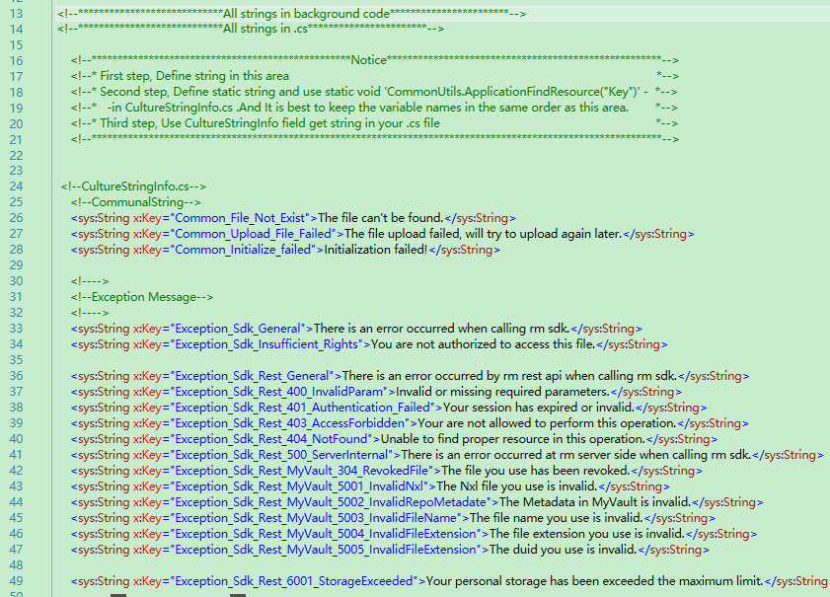

Second step, Define static string and use static void 'CommonUtils.ApplicationFindResource("Key")' in CultureStringInfo.cs .And It is best to keep the variable names in the same order as this area.

‘CultureStringInfo.cs’ url:SkydrmLocal/rmc/ui/CultureStringInfo.cs

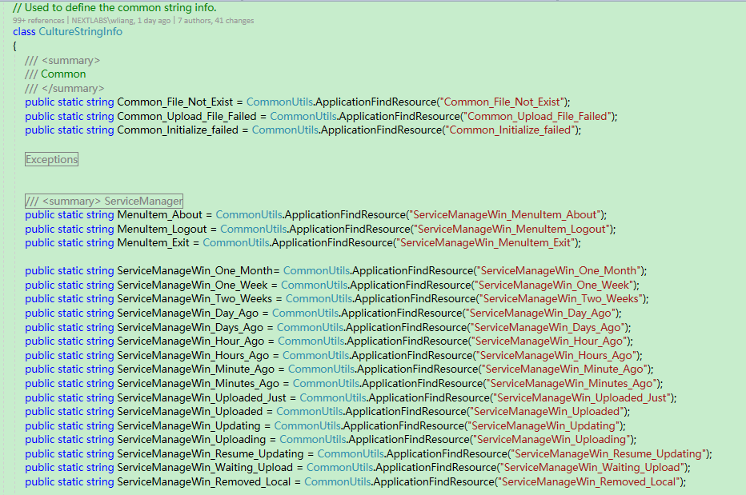

Third step, Use CultureStringInfo field get string in your .cs file

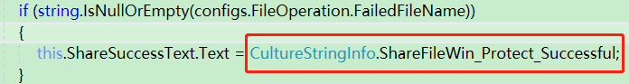

Second part: All the strings in the .xaml file are added in this section.

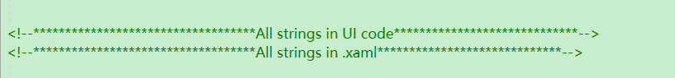

Steps: First step, Define string in this area.(Communal strings in begins, the other strings are sorted separately)

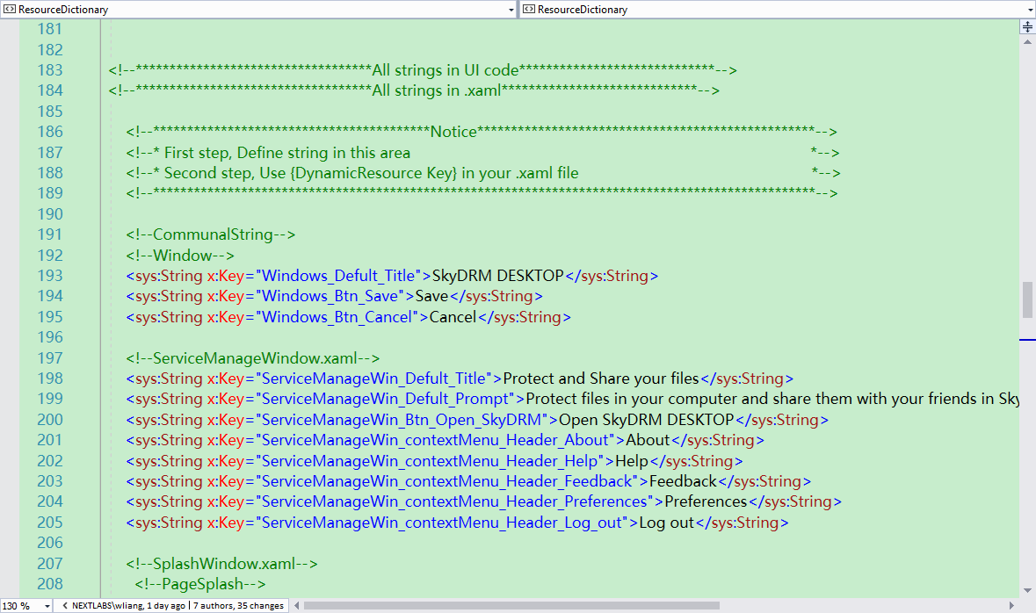

Second step, Use {DynamicResource Key} in your .xaml file

